

Pax Place - Holiday Let

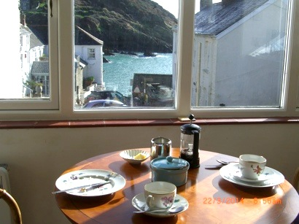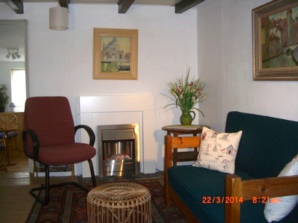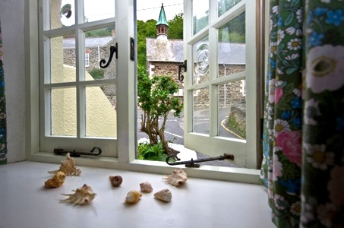Pax Place, Portloe, Cornwall, TR2 5QX

2015 - Particulars, Terms and Conditions

Pax Place is a good base whether you wish to walk, recharge your batteries, chill out or explore Cornwall

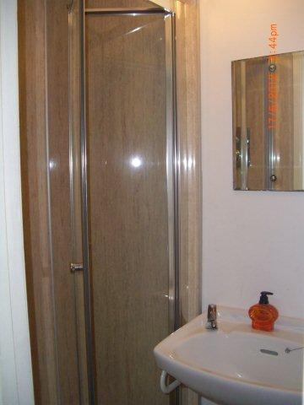

Pax Place

Enter Pax Place with its view across the harbour is tucked away opposite the Church and telephone box in the centre of Portloe and entered through the dark blue door. Enjoy a cup of tea or evening drink in the kitchen/dining beyond with the stream alongside looking out at the harbour and sleep peacefully upstairs in the bedroom with 4'6" double bed (no end) overlooking the Jacka and cliff without being disturbed by early morning delivery vehicles. The shower, wc and handbasin are off the landing. Have an early morning swim in the harbour before enjoying the day.

Arrival/Departure: Friday. Linen provided. No towels or beach towels.

Equipment: Refrigerator with small freezer compartment, microwave/oven, electric hob,

clothes washing machine and kettle, toaster, TV with DVD, radio, books, cards and board games. Electric thermostatically controlled wall panel heaters.

Parking is often possible between Pax Place and the harbour. If no spaces there is a car park about 5 minutes walk away.

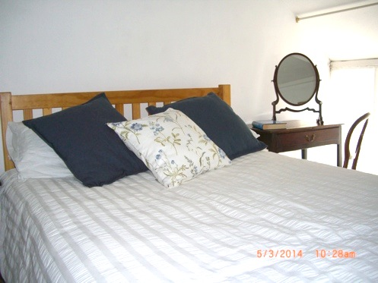Directions…

**By Car:** From Tregony follow signs to Veryan/St Mawes until petrol

station and shop where you fork left. Continue until sign to Portloe to

left. Keep on the road down the hill and continue past car park to Church and phone box on your right.

**By Train and Bus:** To Truro and occasional bus to Portloe.

**By Plane:** to Newquay.

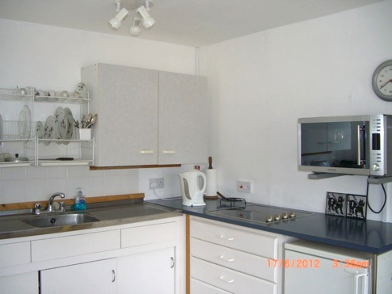 Local Area…

Swim in Portloe harbour or at Carne/Pendower beach.

Walk the costal path passing the door and other footpaths

Eat out in Portloe at the Ship, Lugger Hotel or nearby at the Nare Hotel.

Explore National Trust and other properties and gardens

Buy newspapers and shop at Texaco garage (passed on your way to Portloe) or shops in Veryan and Tregony.

Bus stop to Truro outside the Church.

Terms & Conditions...

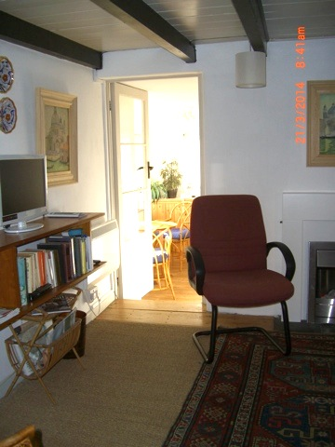Accommodation for 1 or 2 adults.

Sorry, no pets, children or smoking allowed.

Week commences 4.30pm on the first Friday of your holiday and ends at 10am on the Friday of your departure.

Deposit: £100.00

Payment: Due four weeks before your holiday starts. Non payment of the balance of the rent by the due date shall be construed as a cancellation of the contract. If Pax Place cannot be re-let you will be responsible for the full cost of the holiday.  If Pax Place unavailable due to circumstances outside my control the rental money received will be returned.

Key: Arrangements will be posted on completion of payment for holiday let with inventory.

Please check when you arrive and let me know of any missing items or breakages. Complaints cannot be accepted after the tenancy has ended.

The hirer is responsible for any loss or damage to the property (reasonable wear and tear excluded), for taking good care of Pax Place and leaving it in a clean and tidy condition. Should it be found that an excessive amount of cleaning is required a charge will be made.

Electricity is included in the rent except in low season.

Broadband may be accessed through BT Fon.

All information is given in good faith and no responsibility taken for any errors or omissions.

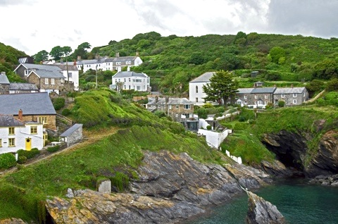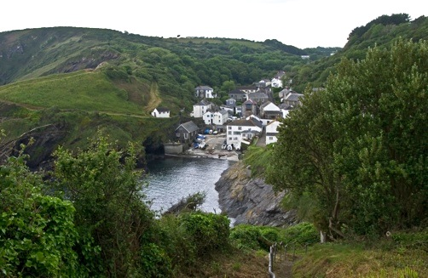

Availability 2015 …

|  |  |  |  |
| --- | --- | --- | --- |
| **Dates** | **Price for 7 nights (£)** | | |
| 2nd January to 3rd April | | £ 334.00 |
| 3rd April to 22nd May | | £ 434.00 |
| 22nd May to 29th May | | £ 525.00 |
| 29th May to 28th August | | £ 484.00 |
| 28th August to 4th September | | £ 525.00 |
| 4th September to 18th December | | £ 464.00 |
| 18th December to 8th January 2016 | | £ 525.00 |

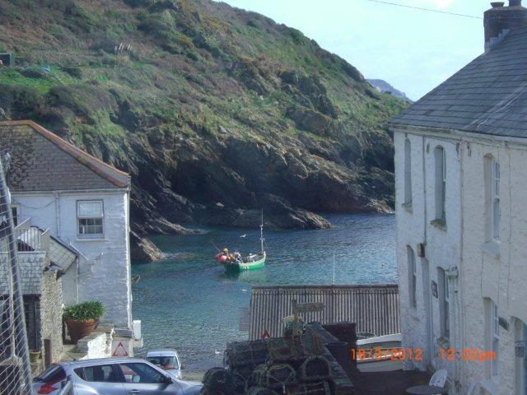  
 Contact Details…

For further information about Pax Place or to confirm availability

(Please remember to state the planned date of your visit and duration):

Email: [jenpax1@yahoo.co.uk](mailto:jenpax1@yahoo.co.uk) Telephone: 01386 840272

Booking Form for 2015…

Please complete the following details and send with cheque to: -

Mrs A. J. Kissel, Garden Cottage, Chipping Campden, GL55 6AL



Name(1): ................................................................................................................................

Name(2) .................................................................................................................................

Address:.................................................................................................................................

…………………………..............................................................................................................

..................................................................... Postcode: ........................................................

Telephone Number: ……………………………............. Mobile Number: ................................................

Email: ......................................................................................... Nationality..........................

Dates From: Friday ................................................................ To: Friday ........................................................... 2015

Deposit: £100.00

Signed (1): ............................................................................. Date: …………………………………………...................... 2015

Signed (2): ……………………………………………............................... Date: ……………………………..……..…...................... 2015